**NGramGUI.java Testcases**

**Positive GUI Test Scenarios:**

**Test Case 1:**

**Input Search Text:** to be

**Number of Suggestions specified by the user:** 11

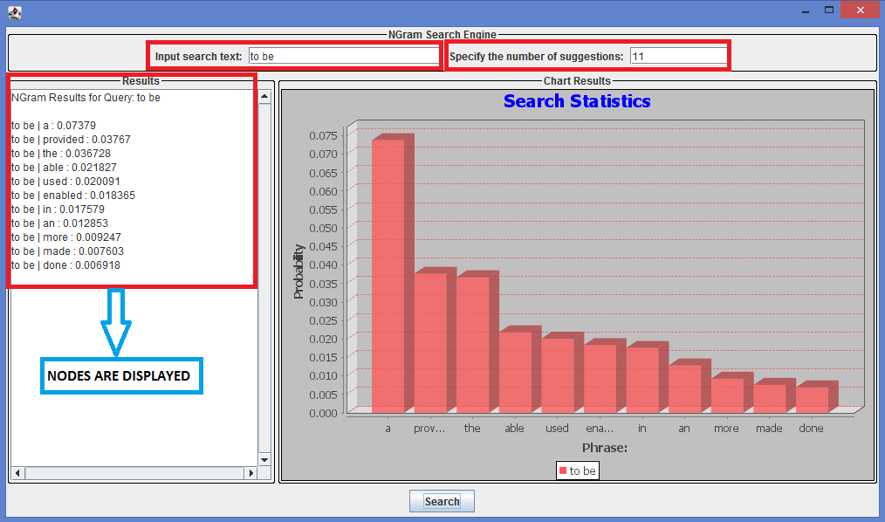

**Screenshot 1**

When a user inputs a search string “**to be**”, specifies the number of suggestions as some random value ‘**11’** and then clicks on the “**Search**” button, the NGram node’s search results are displayed correctly and the probability graph is also displayed on the NGram GUI as shown in the above **Screenshot 1**.

**Test Case 2:**

**Input Search Text:** to be or

**Number of Suggestions specified by the user:** 16

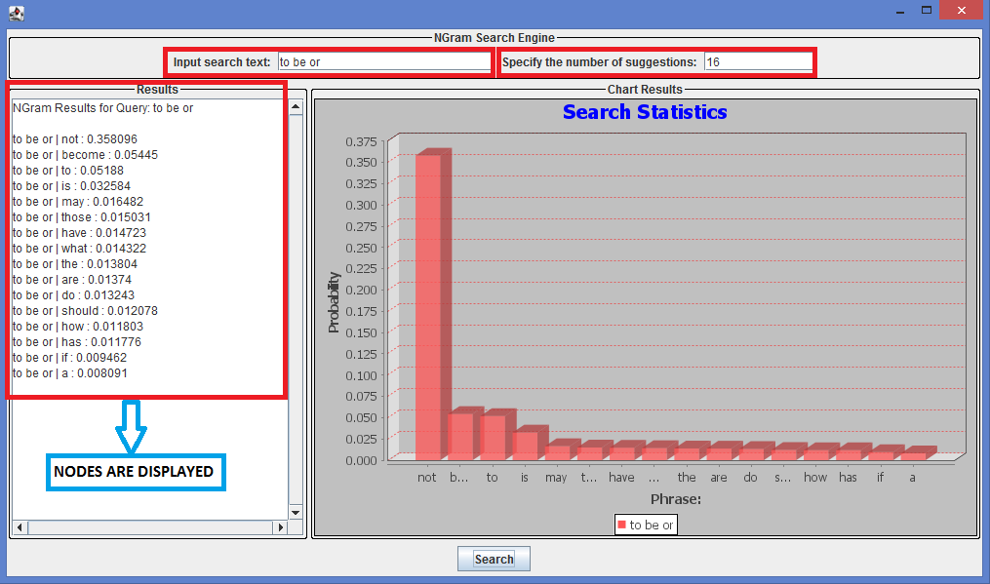

**Screenshot 2**

When a user inputs a search string “**to be or**”, specifies the number of suggestions as some random value ‘**16’** and then clicks on the “**Search**” button, the NGram node’s search results are displayed correctly and the probability graph is also displayed on the NGram GUI as shown in the above **Screenshot 2**.

**Test Case 3:**

**Input Search Text:** to be or not

**Number of Suggestions specified by the user:** 12

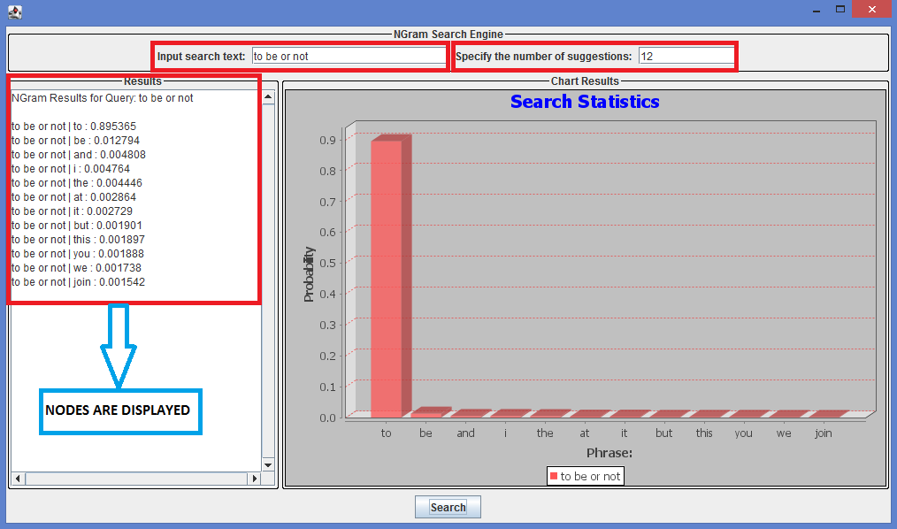

**Screenshot 3**

When a user inputs a search string “**to be or not**”, specifies the number of suggestions as some random value ‘**12’** and then clicks on the “**Search**” button, the NGram node’s search results are displayed correctly and the probability graph is also displayed on the NGram GUI as shown in the above **Screenshot 3**.

**Test Case 4:**

**Input Search Text:** to be or not to

**Number of Suggestions specified by the user:** 14

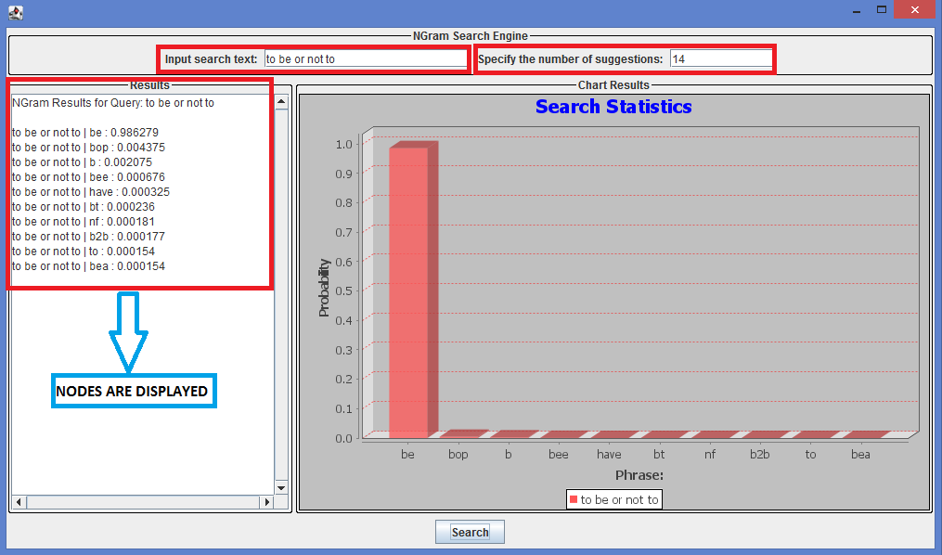

**Screenshot 4**

When a user inputs a search string “**to be or not to**”, specifies the number of suggestions as some random value ‘**14’** and then clicks on the “**Search**” button, the NGram node’s search results are displayed correctly and the probability graph is also displayed on the NGram GUI as shown in the above **Screenshot 4**.

**Test Case 5:**

**Input Search Text:** abcde

**Number of Suggestions specified by the user:** 5

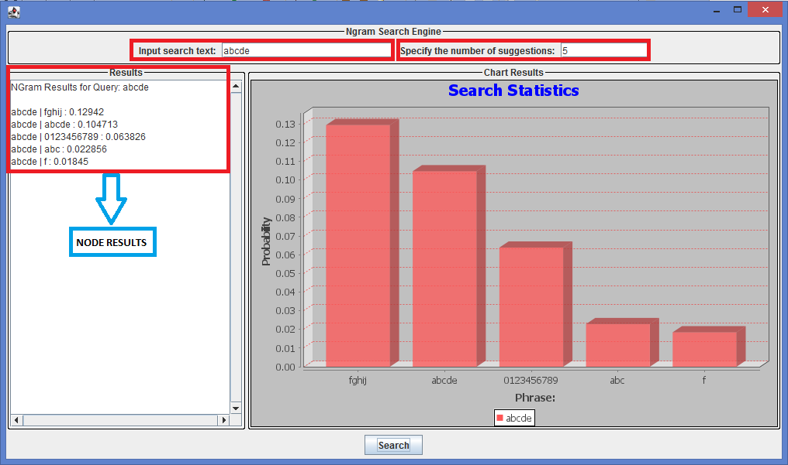

**Screenshot 5**

When a user inputs a search string “**abcde**”, specifies the number of suggestions as some random value ‘**5’** and then clicks on the “**Search**” button, the NGram node’s search results are displayed correctly and the probability graph is also displayed on the NGram GUI as shown in the above **Screenshot 5**.

**Test Case 6: Input Search Text:** abcdef,test

**Number of Suggestions specified by the user:** 4

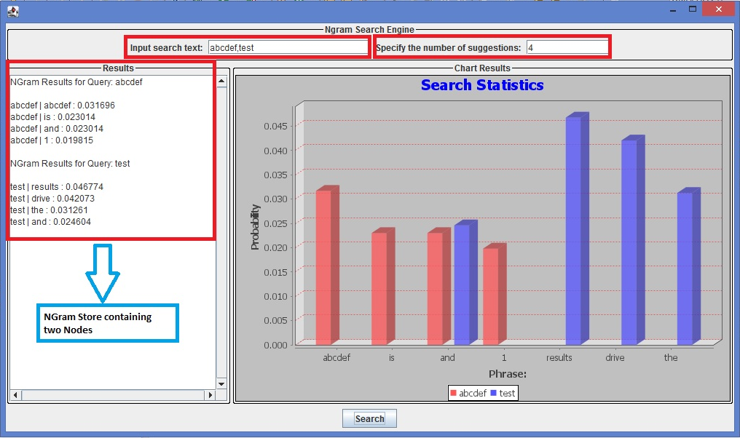

**Screenshot 6**

When a user enters an input search string “**abcdef,test**”, specifies the number of suggestions as some random value ‘**4’** and then clicks on the “**Search**” button, the search results of the NGram store containing two nodes are displayed as indicated in the Left Hand Side of **Screenshot 6**. This is because, the search results of “**abcdef**”are displayed on node 1 and the search result for ‘**test**’ is displayed on node 2. Also, the probability graph is shown on the NGram GUI as indicated in the **Screenshot 6**.

**Test Case 7: Input Search Text:** abcd, abcd, abcd

**Number of Suggestions specified by the user:** 6

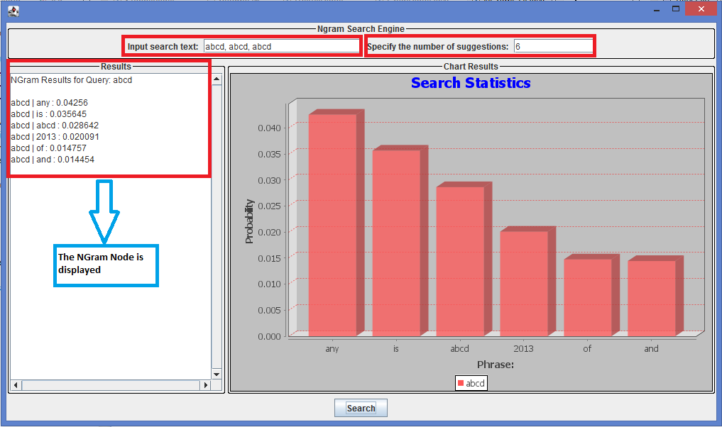

**Screenshot 7**

When a user enters an input search string “**abcd, abcd, abcd**”, specifies the number of suggestions as some random value ‘**6’** and then clicks on the “**Search**” button, the corresponding search results of the NGram node are displayed accordingly by checking its redundancy and displaying the node results for only one input as indicated in the Left Hand Side of **Screenshot 7** and the probability graph is also shown on the NGram GUI.

**Test Case 8: Input Search Text:** Please, tell, me, your

**Number of Suggestions specified by the user:** 3

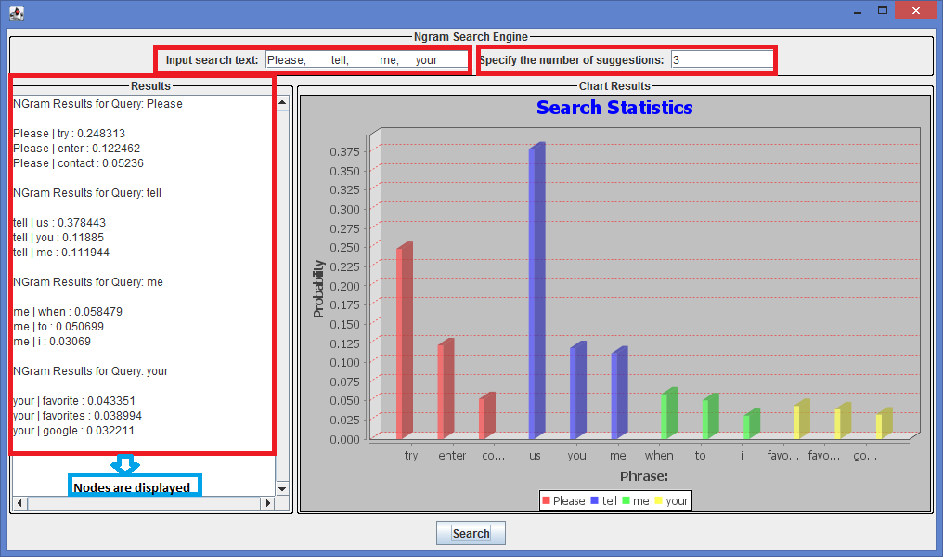

**Screenshot 8**

When a user enters an input search string “**Please, tell, me, your**”, specifies the number of suggestions as some random value ‘**3’** and then clicks on the “**Search**” button, the corresponding three search results of the NGram node are displayed correctly inside the store as indicated in the Left Hand Side of **Screenshot 8** and the probability graph is also shown on the NGram GUI.

**Test Case 9: Input Search Text:** abcd1234

**Number of Suggestions specified by the user:** 15

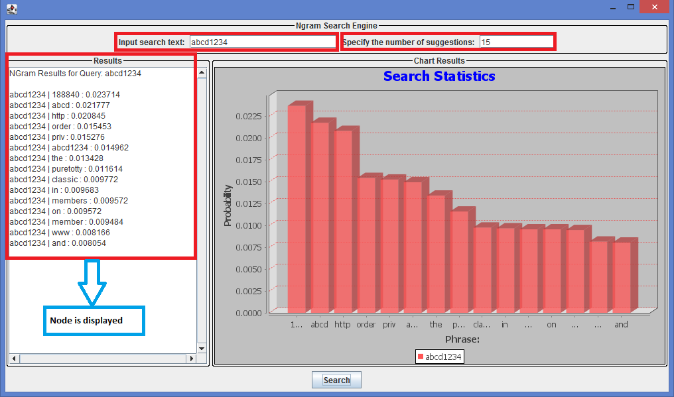

**Screenshot 9**

When a user inputs a search string “**abcd1234**”, specifies the number of suggestions as some random value ‘**15’** and then clicks on the “**Search**” button, the NGram node’s 15 search results are displayed correctly as shown in the left hand side of the above **Screenshot 9** and the probability graph is also shown on the NGram GUI.

**Test Case 10: Input Search Text:** I’am doing this for

**Number of Suggestions specified by the user:** 23

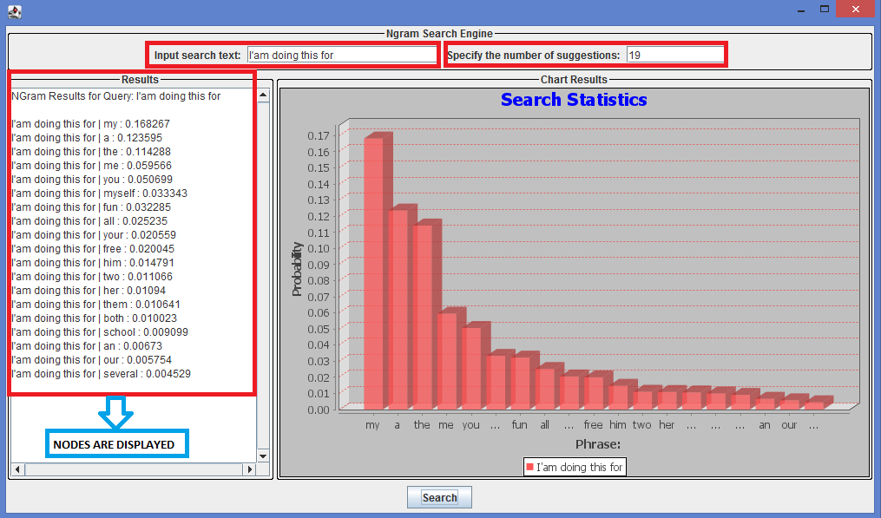

**Screenshot 10**

When a user inputs a search string “**I’am doing this for**”, specifies the number of suggestions as some random value ‘**19’** and then clicks on the “**Search**” button, the NGram node’s 19 search results are displayed correctly as shown in the left hand side of the above **Screenshot 10** and the probability graph is also shown on the NGram GUI.

**Test Case 11: Input Search Text:** 12345

**Number of Suggestions specified by the user:** 22

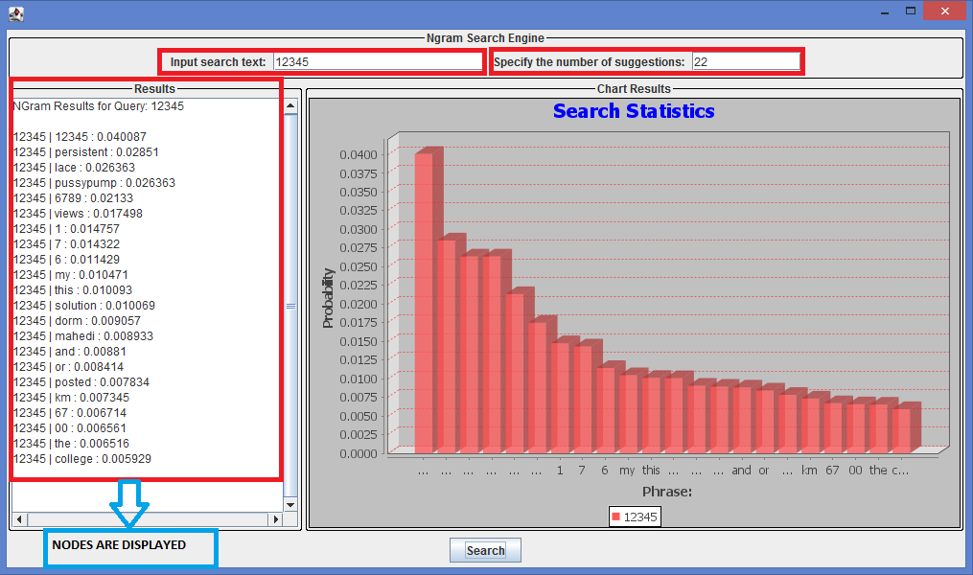

**Screenshot 11**

When a user inputs a search string “**12345**”, specifies the number of suggestions as some random value ‘**22’** and then clicks on the “**Search**” button, the NGram node’s 22 search results are displayed correctly as shown in the left hand side of the above **Screenshot 11** and the probability graph is also shown on the NGram GUI.

**Test Case 12: Input Search Text:** abcde, pqrst, vwxyz, klmno

**Number of Suggestions specified by the user:** 9

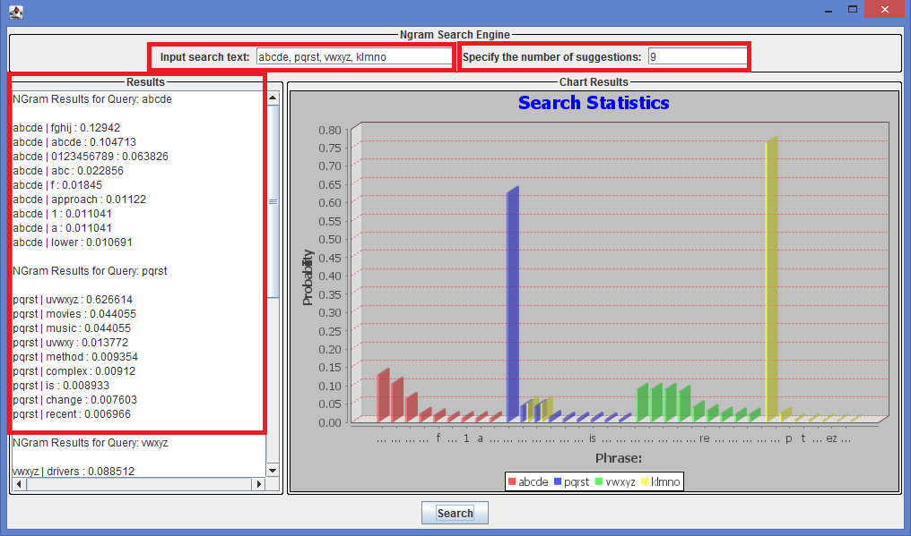

**Screenshot 12 (The first set of node results displayed above the scrollbar)**

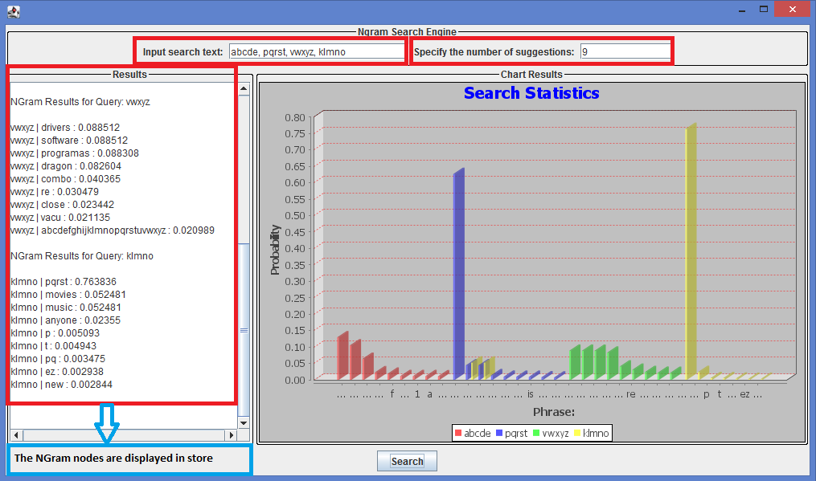

**Screenshot 13 (The remaining node results displayed below the scrollbar)**

When a user inputs a search string “**abcde, pqrst, vwxyz, klmno**”, specifies the number of suggestions as some random value ‘**9’** and then clicks on the “**Search**” button, the NGram search results having 9 nodes are displayed correctly inside the store by use of a scrollbar as shown in the left hand side of the above **Screenshot 12** and **Screenshot 13** and the probability graph is also shown on the NGram GUI.

**Test Case 13**: **Input Search Text:** a,b,c

**Number of Suggestions specified by the user:** 7

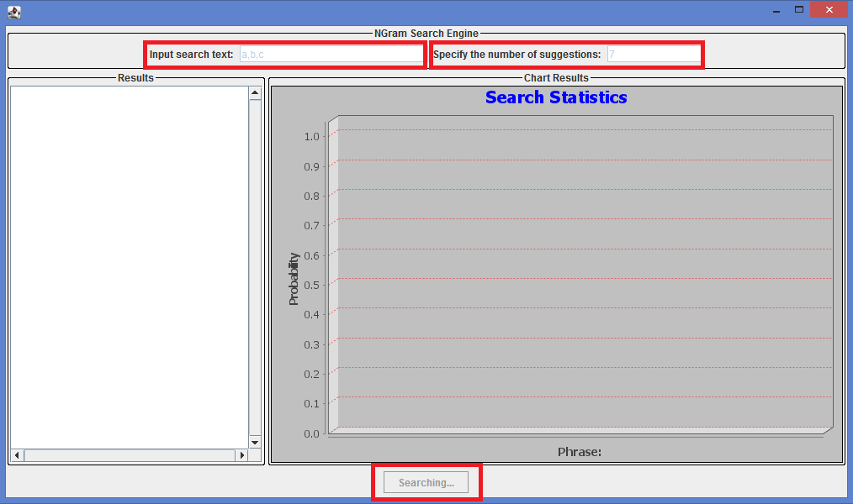

**Screenshot 14**

When a user inputs a search string **“a,b,c**” specifies the number of suggestions as some random value ‘**7**’ and then clicks on the “**Search**” button, the GUI is not blocked and the NGram search engine is still “Searching…” for the node results. The textboxes and the Search button are disabled till the search completes as indicated in the above **Screenshot 14**.

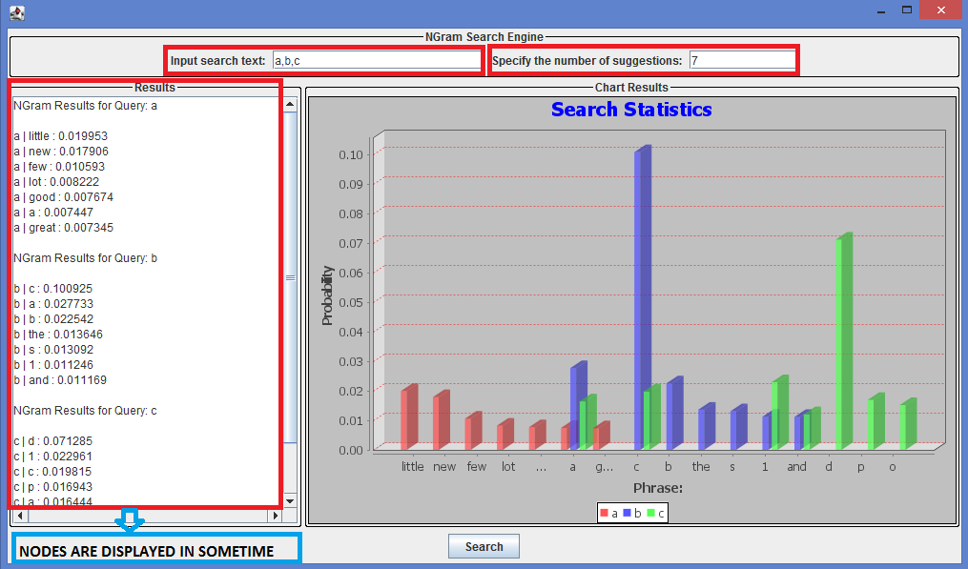

**Screenshot 15**

After the search completes successfully and the results are retrieved by the NGram engine, the nodes are displayed in the store as shown in the left hand side of the **Screenshot 15**.

**Negative GUI Test Scenarios:**

**Test Case 1: Input Search Text:** abc, test, - -

**Number of Suggestions specified by the user:** 4

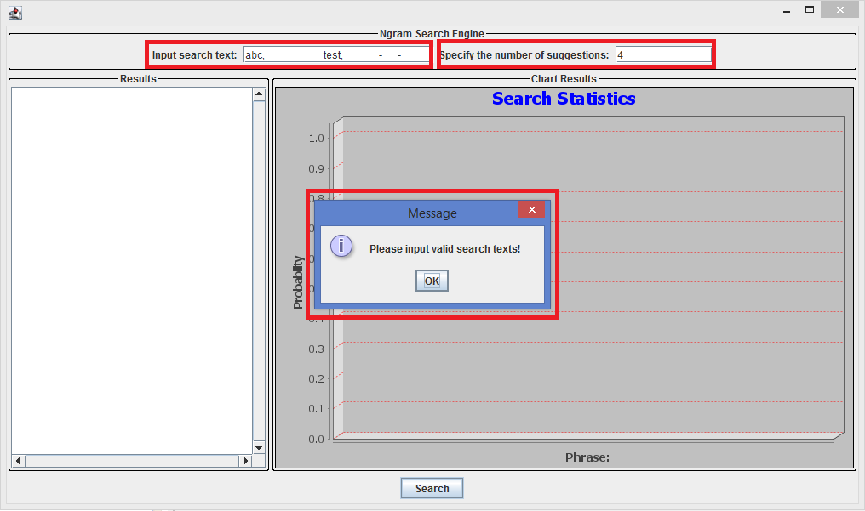

NODES NOT DISPLAYED

**Screenshot 1**

When a user enters an input search string “**abc, test, - -**“, specifies the number of suggestions as some random value ‘**4’** and then clicks on the “**Search**” button, an error message “**Please input valid search texts**” is displayed on a dialog box and the corresponding search results of the NGram node are also **NOT displayed** and the probability graph is also not shown on the NGram GUI as indicated in the above **Screenshot 1**.

**Test Case 2: Input Search Text:** #$123, #%

**Number of Suggestions specified by the user:** 4

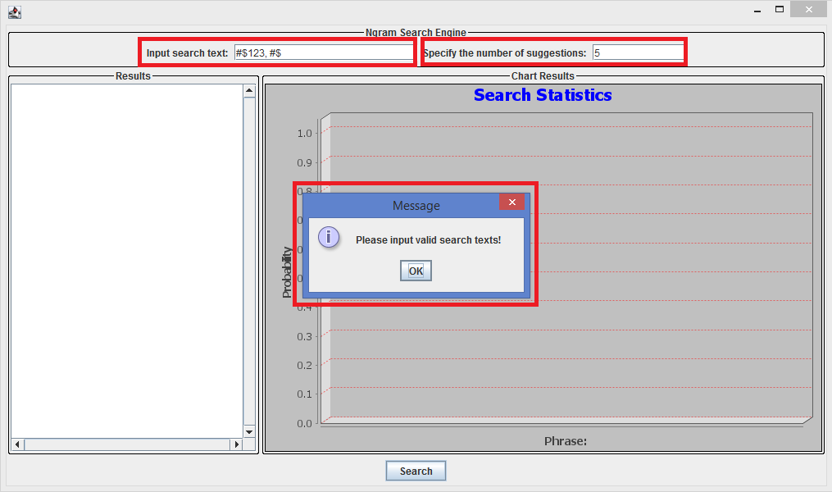

NODES NOT DISPLAYED

**Screenshot 2**

When a user enters an input search string **“#$123, #%**“, specifies the number of suggestions as some random value ‘**5’** and then clicks on the “**Search**” button, an error message “**Please input valid search texts**” is displayed on a dialog box and the corresponding search results of the NGram node are also **NOT displayed** i.e., the store is empty and the probability graph is also not shown on the NGram GUI as indicated in the above **Screenshot 2**.

**Test Case 3: Input Search Text:** a ,_, _,-

**Number of Suggestions specified by the user:** 8

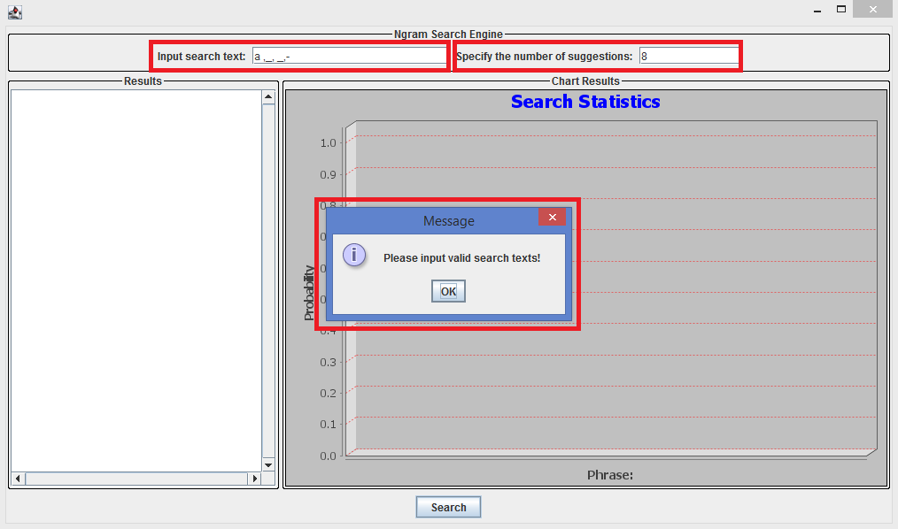

NODES NOT DISPLAYED

**Screenshot 3**

When a user enters an input search string “**a ,_, _,-**“ specifies the number of suggestions as some random value ‘**8’** and then clicks on the “**Search**” button, an error message “**Please input valid search texts**” is displayed on a dialog box and the corresponding search results of the NGram node are also **NOT displayed** i.e., the store is empty and the probability graph is also not shown on the NGram GUI as indicated in the above **Screenshot 3**.

**Test Case 4: Input Search Text:** 938525956

**Number of Suggestions specified by the user:** 10

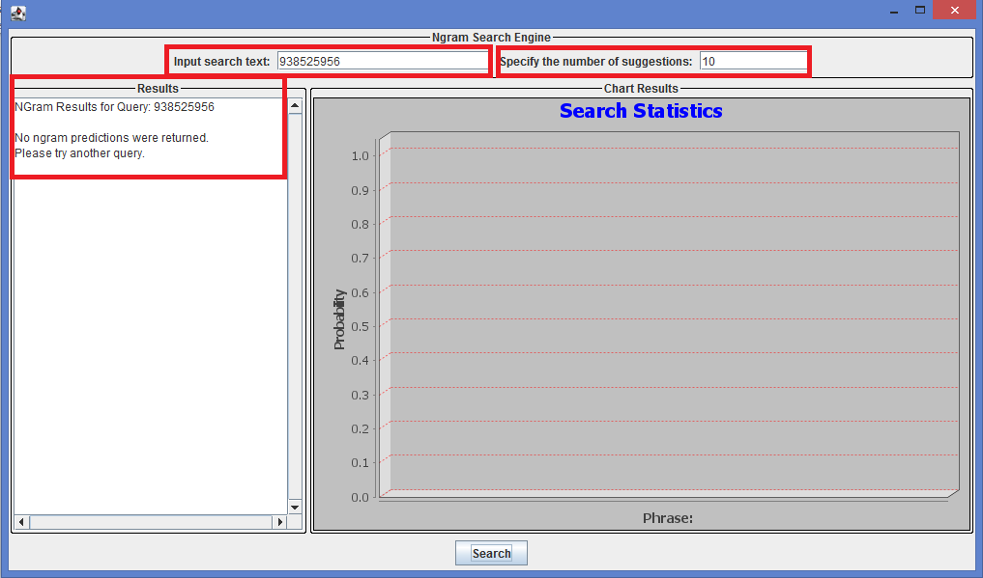

**Screenshot 4**

When a user enters a random number input “**938525956**”, specifies the number of suggestions as some random value ‘**10’** and then clicks on the “**Search**” button, there are no search results displayed and an error message “**No ngram predictions were returned. Please try another query**” is displayed on the node i.e., the store is empty and the probability graph is also not shown on the NGram GUI as indicated in the above **Screenshot 4**.

**Test Case 5: Input Search Text:** 123, $

**Number of Suggestions specified by the user:** 5

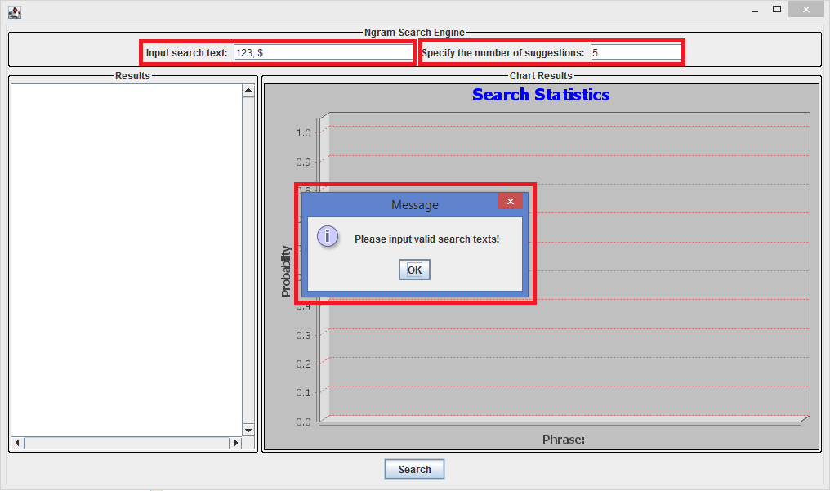

NODES NOT DISPLAYED

**Screenshot 5**

When a user enters a random number input “**123, $**”, specifies the number of suggestions as some random value ‘**5’** and then clicks on the “**Search**” button, an error message “**Please input valid search texts**” is displayed on a dialog box and the corresponding search results of the NGram node are also **NOT displayed** i.e., the store is empty and the probability graph is also not shown on the NGram GUI as indicated in the above **Screenshot 5**.

**Test Case 6: Input Search Text:** , , , , , , , , , , , , ,

**Number of Suggestions specified by the user:** 21

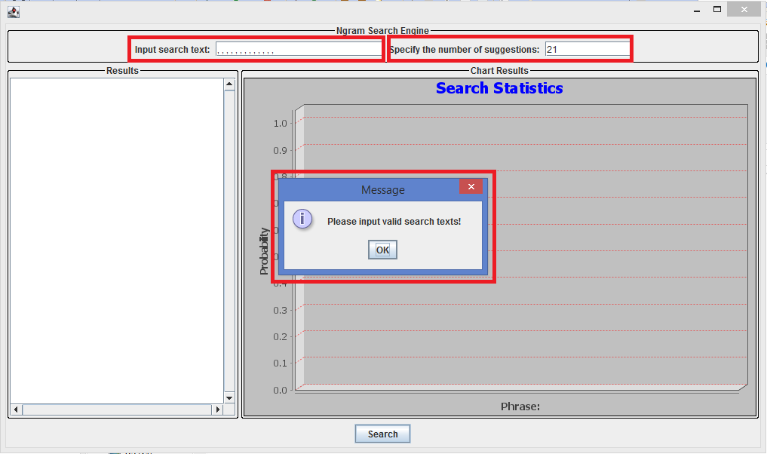

NODES NOT DISPLAYED

**Screenshot 6**

When a user enters a random number input “**, , , , , , , , , , , , ,**”, specifies the number of suggestions as some random value ‘**21’** and then clicks on the “**Search**” button, an error message “**Please input valid search texts**” is displayed on a dialog box and the corresponding search results of the NGram node are also **NOT displayed** i.e., the store is empty and the probability graph is also not shown on the NGram GUI as indicated in the above **Screenshot 6**.

**Test Case 7: Input Search Text:** GDHFTHBNRMNK

**Number of Suggestions specified by the user:** 16

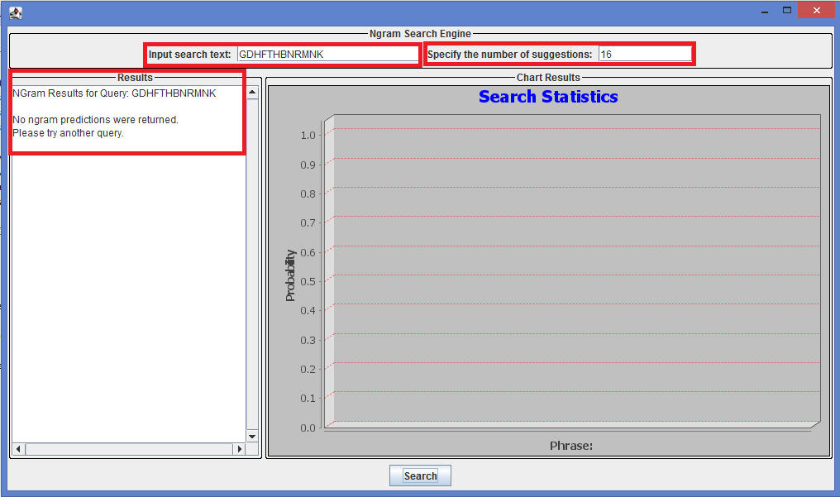

**Screenshot 7**

When a user enters a random number input “**GDHFTHBNRMNK**”, specifies the number of suggestions as some random value ‘**16’** and then clicks on the “**Search**” button, an error message “**Please input valid search texts**” is displayed on a dialog box and the corresponding search results of the NGram node are also **NOT displayed** i.e., the store is empty and the probability graph is also not shown on the NGram GUI as indicated in the above **Screenshot 7**.

**Test Case 8: Input Search Text:** UP$#!@*&

**Number of Suggestions specified by the user:** 25

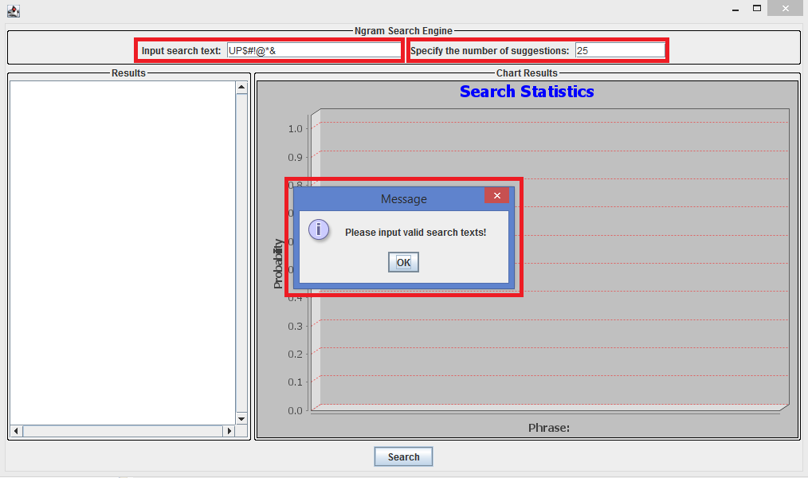

NODES NOT DISPLAYED

**Screenshot 8**

When a user enters a random number input “**UP$#!@*&**”, specifies the number of suggestions as some random value ‘**25’** and then clicks on the “**Search**” button, an error message “**No ngram predictions were returned. Please try another query.**” is displayed in the place of the node and the corresponding search results of NGram node are also **NOT displayed** i.e., the store is empty and the probability graph is also not shown on the NGram GUI as indicated in the above **Screenshot 8**.

**Test Case 9: Input Search Text:** #^76GR, dG, * % ^

**Number of Suggestions specified by the user:** 41

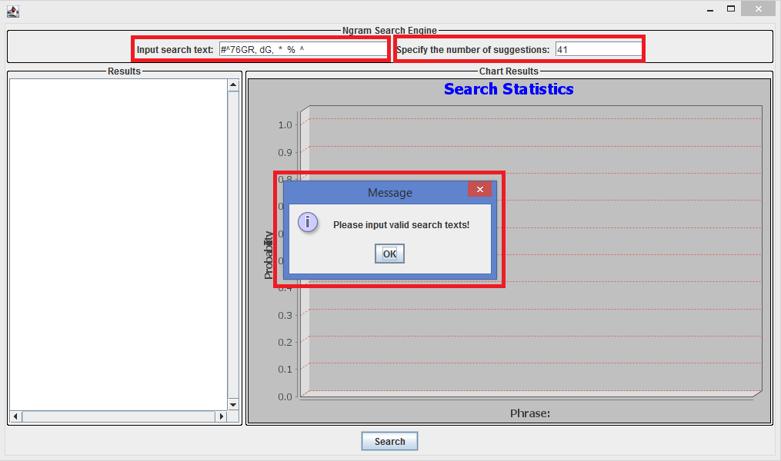

NODES NOT DISPLAYED

**Screenshot 9**

When a user enters an input search string “**#^76GR, dG, * % ^**“, specifies the number of suggestions as some random value ‘**41’** and then clicks on the “**Search**” button, an error message “**Please input valid search texts**” is displayed on a dialog box and the corresponding search results of the NGram node are also **NOT displayed** i.e., the store is empty and the probability graph is also not shown on the NGram GUI as indicated in the above **Screenshot 9**.

**Test Case 10: Input Search Text:** I_am _going_to_perform

**Number of Suggestions specified by the user:** 17

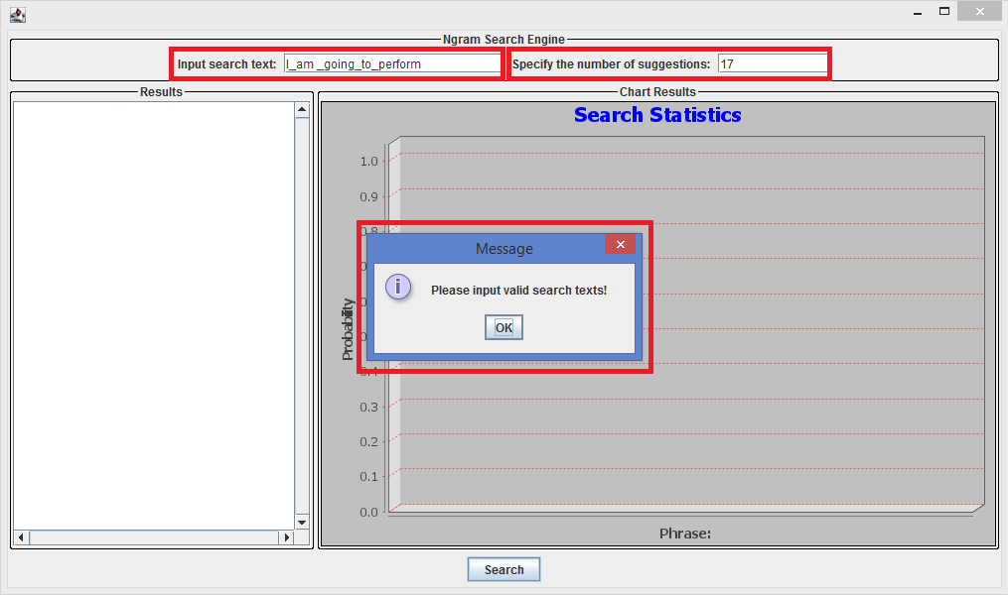

NODES NOT DISPLAYED

**Screenshot 10**

When a user inputs a search string “**I_am _going_to_perform**”, specifies the number of suggestions as some random value ‘**17’** and then clicks on the “**Search**” button, an error message “**Please input valid search texts**” is displayed on a dialog box and the corresponding search results of the NGram node are also **NOT displayed** i.e., the store is empty and the probability graph is also not shown on the NGram GUI as indicated in the above **Screenshot 10**.

**Test Case 11: Input Search Text:** fhjghjgguihu2ht, kjhrjkshtjkhkjhkjafhakj, uwjkshkjhtkjhkjsth

**Number of Suggestions specified by the user:** 37

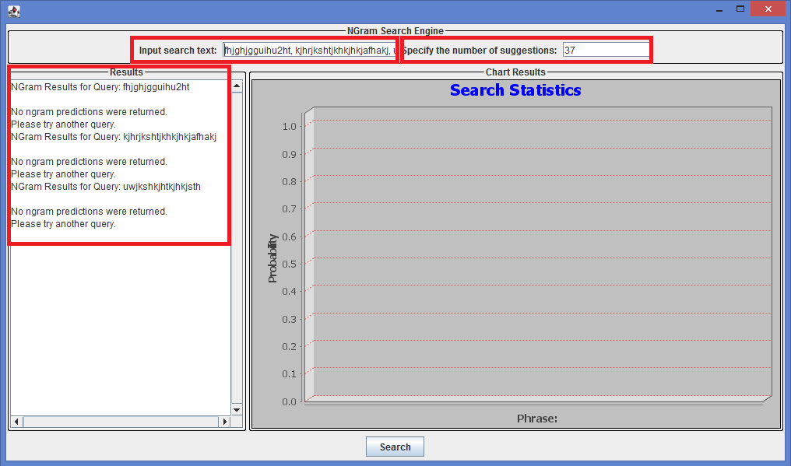

**Screenshot 11**

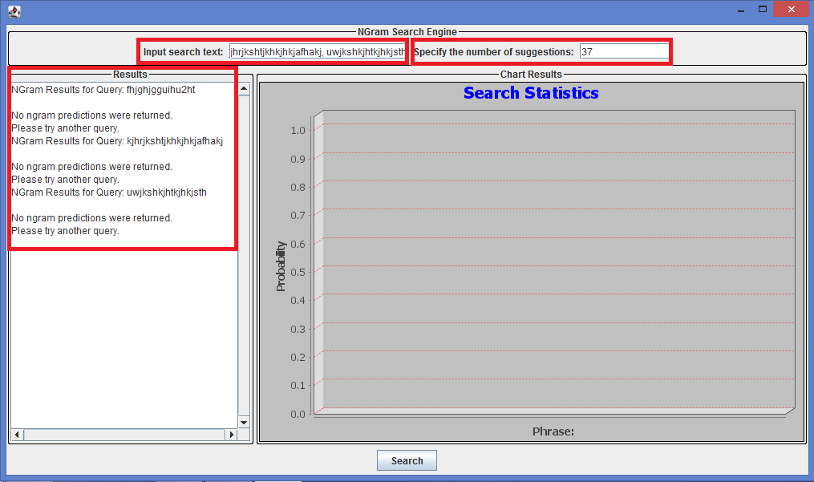

**Screenshot 12**

When a user enters a random number input “**fhjghjgguihu2ht, kjhrjkshtjkhkjhkjafhakj, uwjkshkjhtkjhkjsth**”, specifies the number of suggestions as some random value ‘**37’** and then clicks on the “**Search**” button, there are no search results displayed and an error message “**No ngram predictions were returned. Please try another query**” is displayed on the node i.e., the store is empty and the probability graph is also not shown on the NGram GUI as indicated in the above **Screenshot 11** and **Screenshot 12**.

**Test Case 12: Input Search Text:** MNOP87589376

**Number of Suggestions specified by the user:** 26

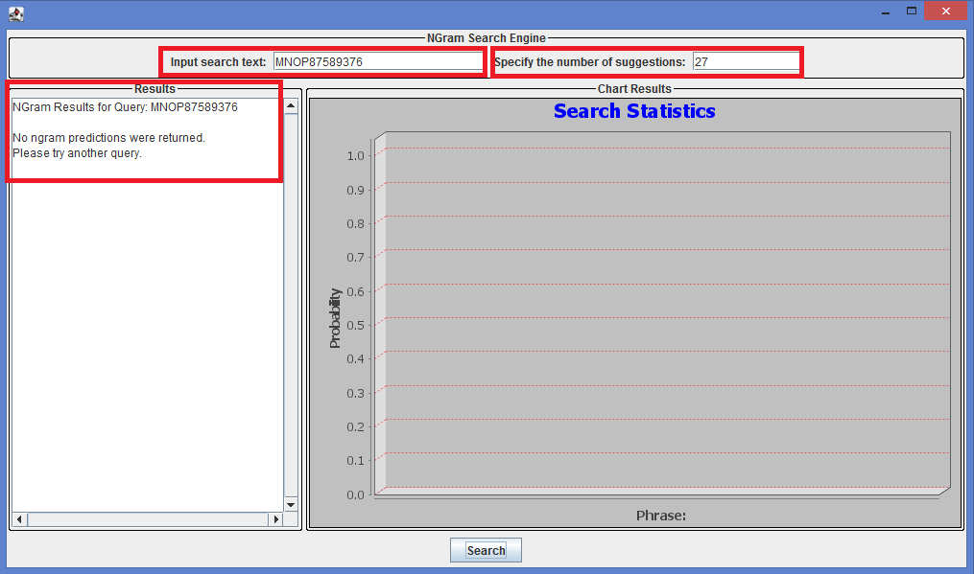

**Screenshot 13**

When a user inputs a search string “**MNOP87589376**”, specifies the number of suggestions as some random value ‘**27’** and then clicks on the “**Search**” button, there are no search results displayed and an error message “**No ngram predictions were returned. Please try another query**” is displayed on the node i.e., the store is empty and the probability graph is also not shown on the NGram GUI as indicated in the above **Screenshot 13**.

**Test Case 13: Input Search Text:** $ dd 978

**Number of Suggestions specified by the user:** 101

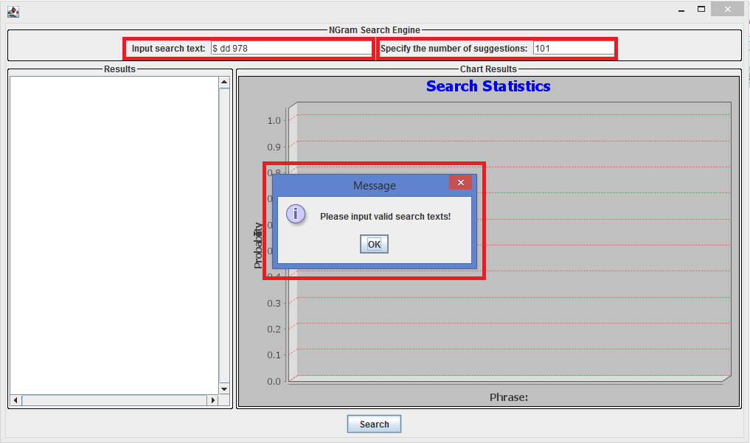

NODES NOT DISPLAYED

**Screenshot 14**

When a user inputs a search string “**$ dd 978**”, specifies the number of suggestions as some random value ‘**101**’ and then clicks on the “**Search**” button, an error message “**Please input valid search texts**” is displayed on a dialog box and the corresponding search results of the NGram node are also **NOT displayed** i.e., the store is empty and the probability graph is also not shown on the NGram GUI as indicated in the above **Screenshot 14**.

**Test Case 14: Input Search Text:** $ trg1352947 , , , , , %^&*^

**Number of Suggestions specified by the user:** 423

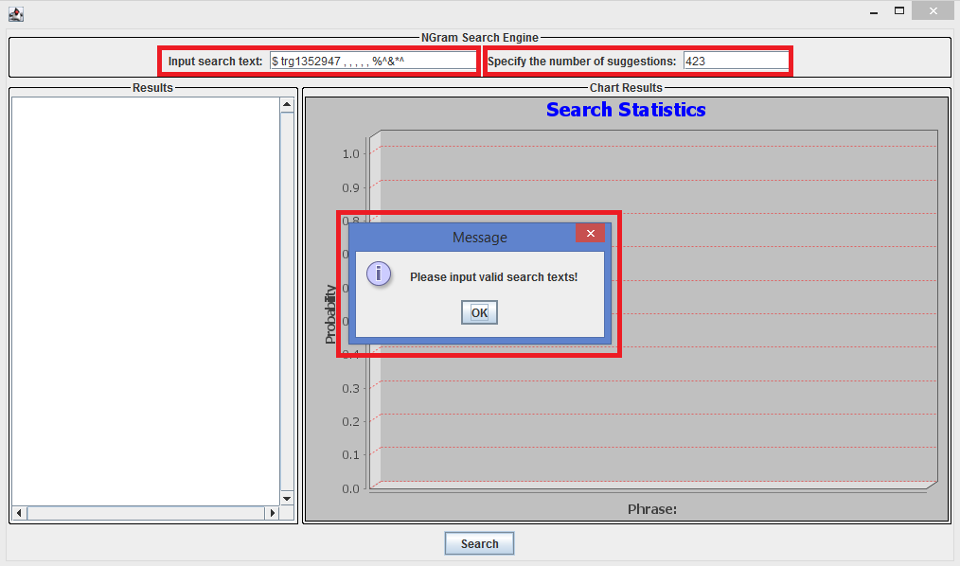

NODES NOT DISPLAYED

**Screenshot 15**

When a user inputs a search string “**$ trg1352947 , , , , , %^&*^**”, specifies the number of suggestions as some random value ‘**423**’ and then clicks on the “**Search**” button, an error message “**Please input valid search texts**” is displayed on a dialog box and the corresponding search results of the NGram node are also **NOT displayed** i.e., the store is empty and the probability graph is also not shown on the NGram GUI as indicated in the above **Screenshot 15**.

**Test Case 15: Input Search Text:** gfhgtggiuqyhwFHWKJ

**Number of Suggestions specified by the user:** 15

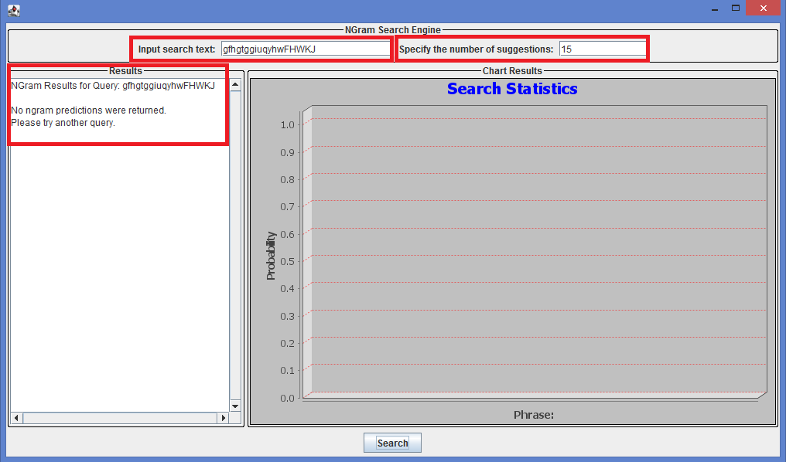

**Screenshot 16**

When a user inputs a search string “**gfhgtggiuqyhwFHWKJ**”, specifies the number of suggestions as some random value ‘**15**’ and then clicks on the “**Search**” button, there are no search results displayed and an error message “**No ngram predictions were returned. Please try another query**” is displayed on the node i.e., the store is empty and the probability graph is also not shown on the NGram GUI as indicated in the above **Screenshot 16**.

**Test Case 16: Input Search Text:** yjsgjksgjksgjwgbifneveogvjngbngvbagbijghnsrkgnk

**Number of Suggestions specified by the user:** 212

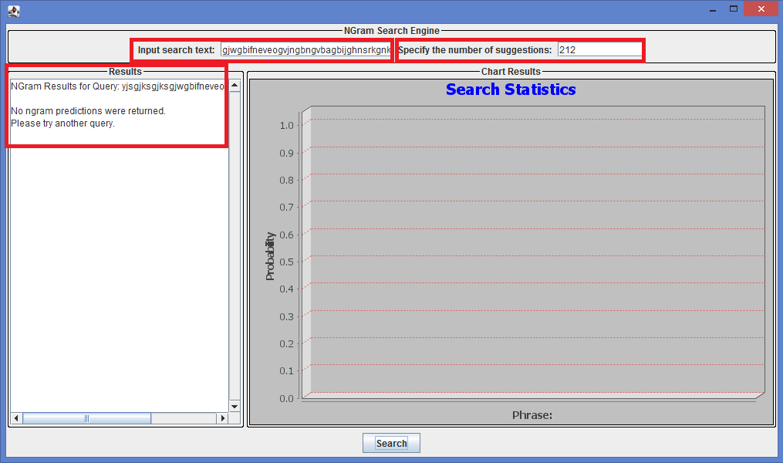

**Screenshot 17**

When a user inputs a search string “**yjsgjksgjksgjwgbifneveogvjngbngvbagbijghnsrkgnk**” specifies the number of suggestions as some random value ‘**212**’ and then clicks on the “**Search**” button, there are no search results displayed and an error message “**No ngram predictions were returned. Please try another query**” is displayed on the node i.e., the store is empty and the probability graph is also not shown on the NGram GUI as indicated in the above **Screenshot 17**.

**Test Case 17: Input Search Text:** fhjbj####wbjwabju99$$$$90098****9080—92+++++u4

**Number of Suggestions specified by the user:** 553

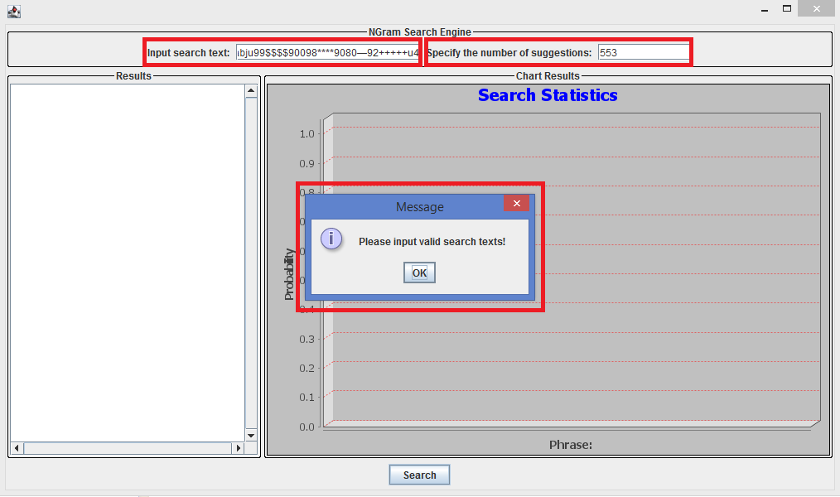

NODES NOT DISPLAYED

**Screenshot 18**

When a user inputs a search string “**fhjbj####wbjwabju99$$$$90098****9080—92+++++u4**” specifies the number of suggestions as some random value ‘**553**’ and then clicks on the “**Search**” button, an error message “**Please input valid search texts**” is displayed on a dialog box and the corresponding search results of the NGram node are also **NOT displayed** i.e., the store is empty and the probability graph is also not shown on the NGram GUI as indicated in the above **Screenshot 18**.

**Test Case 18: Input Search Text:** # *, , , , % ^ 2 3 4 $&@ 976 +-^

**Number of Suggestions specified by the user:** 207

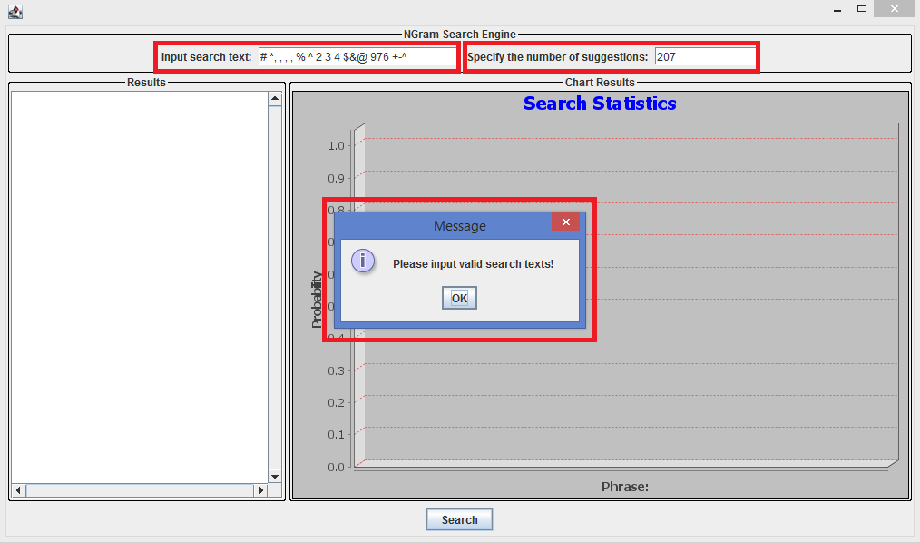

NODES NOT DISPLAYED

**Screenshot 19**

When a user inputs a search string “**# *, , , , % ^ 2 3 4 $&@ 976 +-^**” specifies the number of suggestions as some random value ‘**207**’ and then clicks on the “**Search**” button, an error message “**Please input valid search texts**” is displayed on a dialog box and the corresponding search results of the NGram node are also **NOT displayed** i.e., the store is empty and the probability graph is also not shown on the NGram GUI as indicated in the above **Screenshot 19**.

**Test Case 19: Input Search Text:** , ,test, ,

**Number of Suggestions specified by the user:** 312

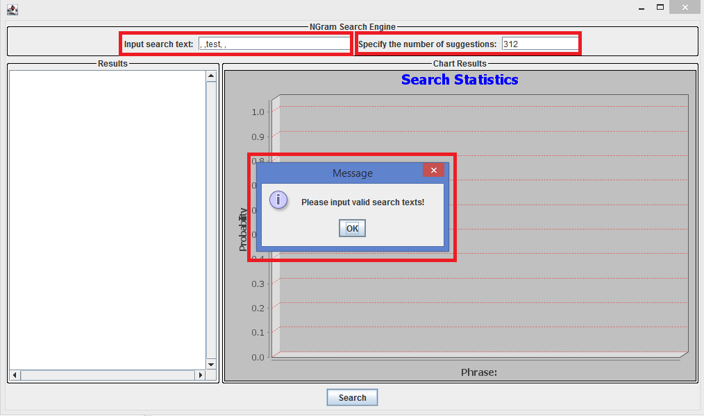

NODES NOT DISPLAYED

**Screenshot 20**

When a user inputs a search string “**, ,test, ,**” specifies the number of suggestions as some random value ‘**312**’ and then clicks on the “**Search**” button, an error message “**Please input valid search texts**” is displayed on a dialog box and the corresponding search results of the NGram node are also **NOT displayed** i.e., the store is empty and the probability graph is also not shown on the NGram GUI as indicated in the above **Screenshot 20**.

**Test Case 20**: **Input Search Text:** , , , , ,test

**Number of Suggestions specified by the user:** 542

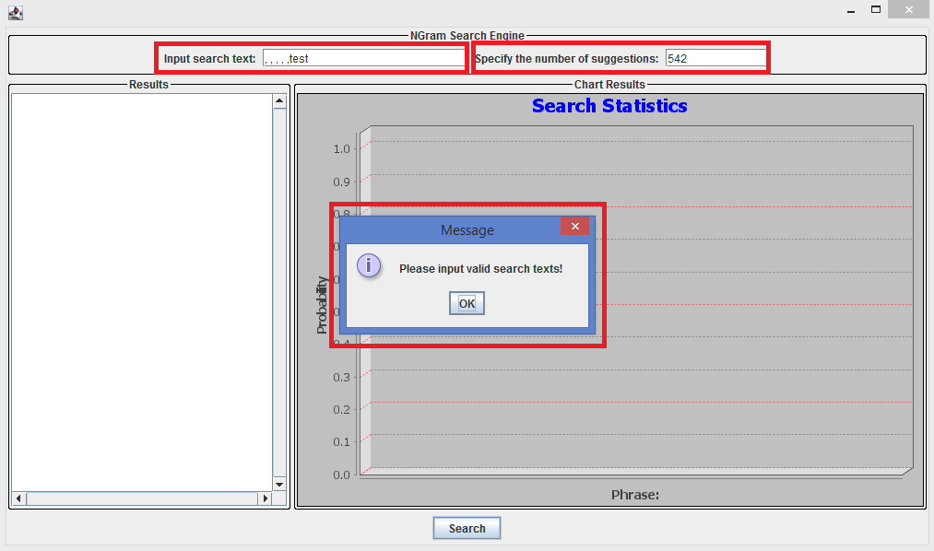

NODES NOT DISPLAYED

**Screenshot 21**

When a user inputs a search string **“, , , , ,test**” specifies the number of suggestions as some random value ‘**542**’ and then clicks on the “**Search**” button, an error message “**Please input valid search texts**” is displayed on a dialog box and the corresponding search results of the NGram node are also **NOT displayed** i.e., the store is empty and the probability graph is also not shown on the NGram GUI as indicated in the above **Screenshot 21**.

**Test Case 21**: **Input Search Text:** ,,,,,test

**Number of Suggestions specified by the user:** 655

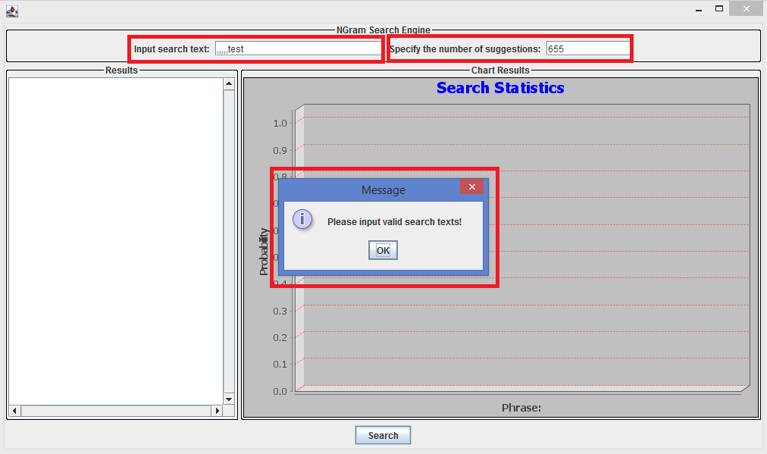

NODES ARE DISPLAYED

**Screenshot 22**

When a user inputs a search string **“,,,,,test**” specifies the number of suggestions as some random value ‘**655**’ and then clicks on the “**Search**” button, an error message “**Please input valid search texts**” is displayed on a dialog box and the corresponding search results of the NGram node are also **NOT displayed** i.e., the store is empty and the probability graph is also not shown on the NGram GUI as indicated in the above **Screenshot 22**.

**Test Case 22**: **Input Search Text:** abc

**Number of Suggestions specified by the user:** 0

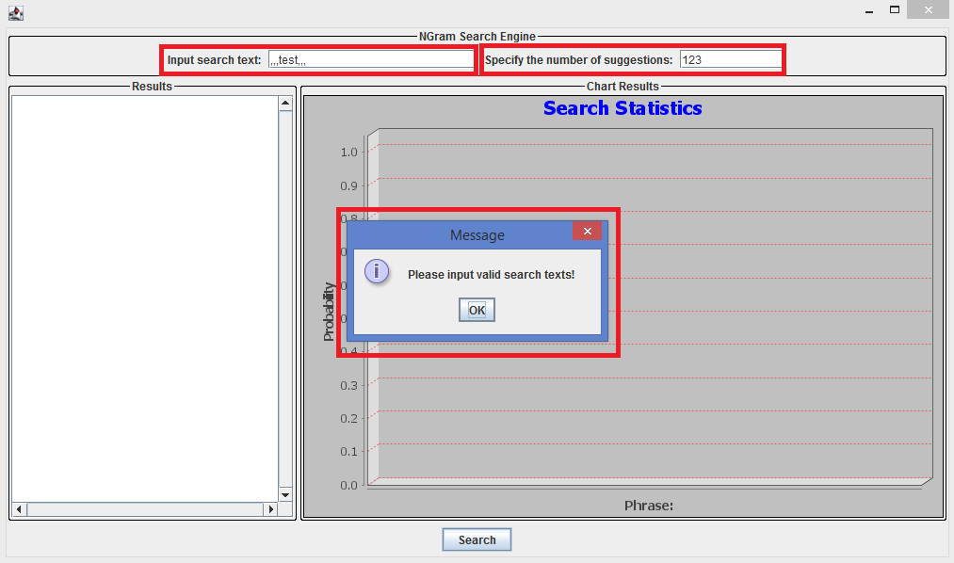

NODES ARE DISPLAYED

**Screenshot 23**

When a user inputs a search string “**abc**” specifies the number of suggestions as some random value ‘**123**’ and then clicks on the “**Search**” button, an error message “**Please input valid search texts**” is displayed on a dialog box and the corresponding search results of the NGram node are also **NOT displayed** i.e., the store is empty and the probability graph is also not shown on the NGram GUI as indicated in the above **Screenshot 23**.

**Test Case 22**: **Input Search Text:** ,,,test,,,

**Number of Suggestions specified by the user:** 123



NODES ARE DISPLAYED

**Screenshot 23**

When a user inputs a search string **“,,,test,,,**” specifies the number of suggestions as some random value ‘**123**’ and then clicks on the “**Search**” button, an error message “**Please input valid search texts**” is displayed on a dialog box and the corresponding search results of the NGram node are also **NOT displayed** i.e., the store is empty and the probability graph is also not shown on the NGram GUI as indicated in the above **Screenshot 23**.